1. Define what the program is to do.
   1. Purpose: Play a game of war using dice between two players.
   2. Input: die sides per player, loaded die or not for each player, number of rounds to play
   3. Output: menu for playing the game, after menu options selected output the results of the game indicating sides and type (loaded/normal) of die, results of each player’s roll per round, and final winner of the game
2. Model the program

* Program starts displaying menu for the game,
  + Menu options are start game, setup player 1 die, setup player 2 die, set number of rounds, or exit
* Setup player 1 die selected
  + prompts user to enter die size for player 1, p1DieSize
  + Prompt user to enter type of die for player 1, p1Type
  + Create p1Die object
    - If p1Type == true then create LoadedDie instead of Die object
* Setup player 1 die selected
  + Prompt user to enter die size for player 2, p2DieSize
  + Prompt user to enter type of die for player 2, p2Type
  + Create p2Die object
    - If p1Type == true then create LoadedDie instead of Die object
* Set number of rounds selected
  + Prompt user to enter rounds to play, gameRounds
* Start game selected
  + Use get functions (getRounds, getSides) to validate that parameters for game are set up prior to running
  + Use Game class to create game object, currentGame
  + Output the sides and type of each players dice
  + playGame method passed number of rounds and controls game
    - loop until required number of rounds go by
    - roll each die once per round using regular or loaded function based on bool type of die
      * loaded function fills array with values corresponding to possible die rolls, plus an extra entry for each of the values that are greater than the mean die roll
      * random number generator returns value corresponding to the possible index spots of the array
      * regular roll function returns random value based purely on the available results from diedie
    - output the results of each roll to the screen each round
    - increment counter to control game loop
    - use tallyScore method to adjust score based on die roll
      * if p1 wins add 1 to score[0]
      * if p2 wins add 1 to score[1]
      * if draw, no score added
    - at end of the game output winner based on score[]
      * if score[0] > score[1] p1 wins
      * if score[1] > score[0] p2 wins
      * else game is a draw
* After game is complete return to the main menu

1. Class hierarchy diagram

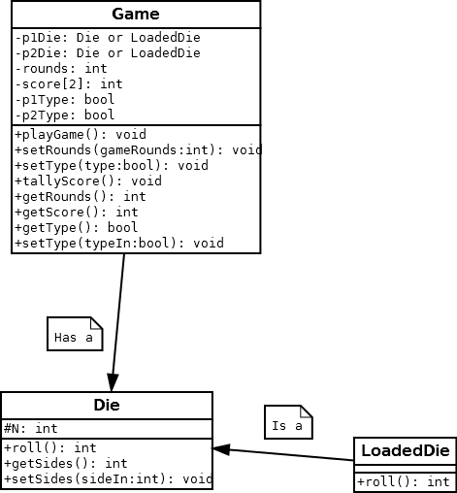

1. Testing Plan

|  |  |  |  |  |
| --- | --- | --- | --- | --- |
| Test | Input Values | Driver Functions | Expected results | Observed outcomes |
| No input1 | None | main()  while getRounds, getSides ==0 | Testing input validation to prevent game from running with no data |  |
| Integer input validation | spaces  “asdf”  1234asdf | main()  InputValidation function | When creating Die object, or setting rounds from main menu should loop until valid integer input received. |  |
| scoreTally test | 5 rounds with same types of dice  both fair 4 sided  both fair 6 sided  fair 4 sided vs fair 10 sided | main()  playGame()  roll()  tallyScore() | Should have proper output in the event of either player winning, or a draw. |  |
| Loaded roll output | 15 rounds with loaded and regular 6 sided dice | main()  playGame()  roll()  LoadedDie roll() | Expect to be able to see divergent averages between loaded and regular roll showing a bias toward the numbers greater than the average. |  |